


Analysis of MPLS Signaling Protocols and Traffic Dissemination in OSPF
and MPLS
Sang-Chul Kim^{O} and Jong-Moon Chung
Department of Computer Science, Kookmin University
sckim7@kookmin.ac.kr
School of Electrical Engineering, Yonsei University
jmc@yonsei.ac.kr

Abstract
This paper analyzes MPLS signaling protocols for traffic engineering, shows the capability of
providing traffic engineering in MPLS compared to the conventional routing protocol, and explains
the MPLS LSR operations based on the basic LSR functionality of classification, queue, and
scheduling. CR-LDP, RSVP and RSVP-TE are summarized and analyzed based on how to set up
LSP for TE with help of protocol messages. In addition, the comparisons of CR-LDP, RSVP, and
RSVP-TE are conducted based on the aspects of LSP reliability and LSP adaptability. A
performance metric such as throughput is adopted in order to measure the capability of MPLS
traffic engineering based on computer-based simulation.

1. Introduction

The explosive growth of the Internet over past a few
years has made the IP protocol suite the most
predominant networking technology. Furthermore,
the convergence of voice and data communications
over a single network infrastructure is expected to
happen over IP-based networks. Traditional IP
networks offer little predictability of service, which is
unacceptable for applications such as telephony, as
well as for emerging and future real-time applications.
One of the primary goals of traffic engineering is to
enable networks to offer predictable performance.
As recent history tells us, the upper limit of
transmittable bandwidth doubles and sometimes
quadruples every nine to twelve months. Already
transmission of tens of tera bits-per-second over a
single optical fiber is possible and matching data
transferring topologies as well as improved system
reliability are currently needed. Based on the above
facts, two major candidates that are in competition to
become the dominant future network protocol and
network architecture are differential services (DS)
and multiprotocol label switching (MPLS) [1]. In the
competition of DS and MPLS, MPLS has been
emerging as the protocol of the future for the
following reasons. Realizing the features provided by
MPLS makes it an easy choice. First, it is a true
“multiprotocol architecture” utilizing a simple label
switching mechanism, which is where its versatility

in application exists, e.g., MPLS over ATM, frame
relay (FR), etc. Second, through utilizing
classification, queue, and scheduling (CQS) traffic-
engineering topologies MPLS is capable of providing
controllable quality of service (QoS) features [2].
Third, MPLS provides a solution to scalability and
enables significant flexibility in routing. Fourth, the
connection oriented architecture and QoS reliability
features easily enable high quality end-to-end service
features that are necessary in applications such as
virtual private networks (VPN) [3]. These benefits of
MPLS networking are made possible through traffic
engineering. Currently, the constraint-based routing
label distribution protocol (CR-LDP) and the resource
reservation protocol (RSVP) are the signaling
algorithms used for traffic engineering. In this paper,
we compare the signaling procedures of the CR-LDP
and RSVP algorithms and discuss the appropriateness
of the applications in MPLS traffic engineering
networks. Applying MPLS is truly a protocol
architecture matter where the software over the
routers/gateways and switches/bridges need to be
reconfigured to include label edge router (LER) and
label switching router (LSR) functionalities. This
means that the existing network architecture can be
utilized as MPLS architecture without digging out
cables and replacing whole new devices. Although
systems that highly depend on hardware functionality
will unfortunately have to be replaced to include
MPLS architecture. Conventional IP networks reflect

Proceedings of the First Asia International Conference on Modelling & Simulation (AMS'07)
0-7695-2845-7/07 $20.00 © 2007

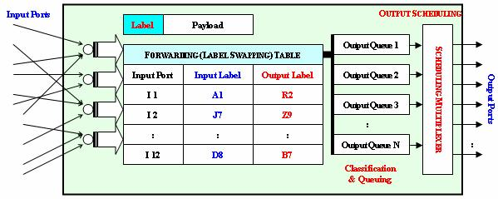

the unpredictable and undifferentiated packet loss and
jitter characteristics of traditional best-effort routers.
Queuing introduces latency and the potential for
packet loss if a queue overflows. In order to provide a
solution to this, this research plan investigates the
requirements of MPLS networking for predictable
differentiated loss, latency, and jitter characteristics to
traffic classes of applications. Also, this paper
provides the construction methods of restoration to
MPLS router for the network facility failures in
operating high speed. This paper is organized as
follows: Section 2 introduces the operation of MPLS
LSR. Sections 3 and 4 explain a detailed explanation
of the CR-LDP and RSVP-TE signaling respectively.
Section 5 compares MPLS signaling protocols based
on LSP reliability and LSP adaptability. Section 6
yields the numerical experiments and results in detail.
Finally, Section 7 summarizes our work and
concludes this paper.

2. MPLS LSR OPERATION

The LSR that conducts the differential services is
required to conduct a three-step procedure to enable
traffic engineering. These three basic steps are
classification, queue, and scheduling (CQS). As label
attached packets arrive at the input ports, the input
label is used to identify the forwarding equivalent
class (FEC) and the corresponding output label. The
output label will replace the input label of the packet.
Then, based on the output label and FEC, the packet
will be sent to the corresponding output queue where
the scheduling multiplexer will decide on the output
order, timing, and the output port for the packet to be
sent out. The setup of the LSR is done by the
signaling protocols (CR-LDP, RSVP-TE). The
functional diagram of a LSR is provided in Fig. 1 [4].

FIG.1. FUNCTIONAL DIAGRAM OF THE LSR CLASSIFICATION, QUEUE,
AND SCHEDULING (CQS) OPERATION.

3. BASIC CR-LDP SIGNALING
CR-LDP standards attempt to enable the LDP
protocol to work over an explicit route, transporting
various traffic parameters for resource reservation as

well as the options for CR-LSP robustness features
[5]. Both LDP and CR-LDP are hard state protocols,
where signaling messages are transmitted once
without any refreshing-information requirements. The
transport mechanism for peer discovery is UDP,
while TCP is used for session, advertisement,
notification, and LDP messages. To setup an explicit
route, a LABEL REQUEST message containing a list
of nodes along the constraint-based route to be
traversed is sent. The signaling message will be sent
to the destination following the selected path, and if
the requested path is able to satisfy the requirements,
labels are allocated and distributed by means of
LABEL MAPPING messages starting with the
destination and propagating in the reverse direction
back to the source. Assuming that resources are
available, the LSP setup is completed after a single
round-trip of the signaling message. CR-LDP is
capable of establishing both strict and loose path
setups with setup and holding priority, path
preemption, and path re-optimization. The procedure
for reporting failures in CR-LDP is based on ingress
and egress router’s TCP layer transport operations.
CR-LDP enables multiprotocol operations by using
an opaque FEC, which allows core LSRs to be
indifferent with respect to the type of traffic being
transported across the network. The opaque FECs are
also used for security purposes as well, not enabling
the LSRs to know the transport data services identity.

4. BASIC RSVP SIGNALING
Based on RFC 2205 [6], the RSVP signaling protocol
standard published by the IETF is intended for soft
state resource reservation focusing on enterprise
networks to support integrated services [7]. RSVP
inherently is a soft state protocol that uses PATH and
RESV commands to establish a LSP. In RSVP, based
on the destination IP address and protocol ID, packets
are transferred based on raw IP datagram routing. The
ingress LSR uses a PATH message to inform every
router along the selected LSP to acknowledge that
this is a desired LSP to be established. Following this,
the receiving LSR will use the RESV message with
traffic and QoS parameters traversing upstream to
reserve the resources on each node along the desired
LSP. The node along the LSP will install the
reservation for the related state by creating an entry
on the label-forwarding table. At every node along
the path, the PATH and RESV messages are used
periodically to refresh the path and reservation states.
Problems in resource reservation can result based on
the RSVP soft state mechanism and the merging
points along the selected LSP. Overall, there is no

Proceedings of the First Asia International Conference on Modelling & Simulation (AMS'07)
0-7695-2845-7/07 $20.00 © 2007

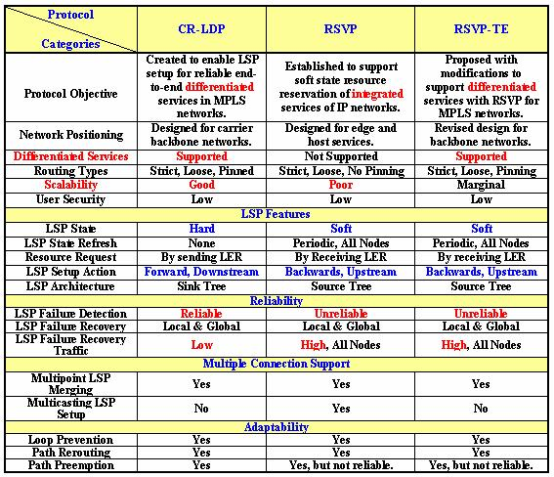

guarantee that the resources will be reserved based on
the end-to-end request.
RSVP-TE has been made and proposed to support
ER-LSP as well as provide additional features to
RSVP [8]. Since the RSVP protocol was proposed to
support MPLS LSP setups, a considerable amount of
modifications and extension have been made to the
original protocol to cope up with the traffic
engineering requirements. The major modifications
and extensions fall into the areas of adding traffic
engineering capabilities and resolving scalability
problems. The revised RSVP protocol has been
proposed to support both strict and loose explicit
routed LSPs (ER-LSP). For the loose segment in the
ER-LSP, the hop-by-hop routing can be employed to
determine where to send the PATH message. Thus,
RSVP also supports hop-by-hop downstream-on
demand ordered mode.

5. COMPARISON OF SIGNALING PROTOCOL
TOPOLOGIES
In this section, the signaling protocols of MPLS
traffic engineering are compared. The signaling
protocols in comparison are the CR-LDP, original
RSVP, and the RSVP-TE. The features of the three
signaling protocols are organized in Table 1 [4].

Table 1. A COMPARISON OF CR-LDP, RSVP, AND RSVP-TE

CR-LDP was created to enable LSP setup for reliable
end-to-end differentiated services in MPLS networks.
Compared to this, RSVP was established to support
soft state resource reservation of integrated services
over IP networks. RSVP was created before CR-LDP
with originally a different intension of where it would
be used. Therefore, it is not surprising that RSVP is
not suitable for traffic engineering in MPLS networks.
The RSVP-TE contains several specifications to

support differentiated services with RSVP for MPLS
traffic engineering networks, although some of the
key components of the architecture are the same. For
example, the original protocol base of using the
internetworking protocol (IP) is the same, also the
hop-by-hop soft state refreshing algorithms are
basically the same (although somewhat modified), as
well as the reverse upstream LSP setup topology
remains the same. Several features of CR-LDP, that
were not a part of RSVP, are now possible by the
RSVP-TE.
As in terms of scalability, CR-LDP is a hard state
protocol, and due to this, it inherently possess better
scaling properties in terms of the volume of signaling
traffic in the network as the number of CR-LSPs
increase. One of the significant drawbacks of RSVP
is its scalability when there are a large number of
paths passing through a node. This is due to the soft
state characteristics of RSVP and RSVP-TE, which
require periodical refreshing of the state for each path.

5-1. LSP RELIABILITY
In RSVP and RSVP-TE signaling for traffic
engineering, the failure notification process contains
several problems. Relying on raw IP creates possible
problems that RSVP may not be able to quickly
inform the edge routers that the connectivity between
them has failed. RSVP-TE does have explicit tear
down messages, but due to relying on raw IP
transporting they are not sent reliably enough. As a
result, the edge LSRs may not start to re-route traffic
until the expiration of the timeout interval. Based on
the recommendations of RFC 2205 [6], 30 seconds of
a refresh interval and 90 seconds of a cleanup timeout
interval have been proposed. These values are
significantly too large for backbone network
operations. If the timing intervals were reduced, the
traffic load due to the refresh operations would create
more scalability problems.
Additionally, to handle loop detection, RSVP-TE
uses the RECORD REROUTE OBJECT, which
provides route information of a certain LSP for route
diagnostic purpose. In order to solve scalability
problems due to the soft state characteristics, RSVP-
TE allows aggregation of the refresh messages to
reduce the total number of transmissions. To reduce
the processing load of these refresh messages on a
node, a MESSAGE ID is introduced with the
intentions of letting the receiving node quickly
identify a state change. However, the use of the ID
needs very careful management of the ID numbers
and messages by the nodes to avoid many possible
errors, such as a mismatch or a duplicate, which
imposes other overheads. The RSVP-TE standards

Proceedings of the First Asia International Conference on Modelling & Simulation (AMS'07)
0-7695-2845-7/07 $20.00 © 2007

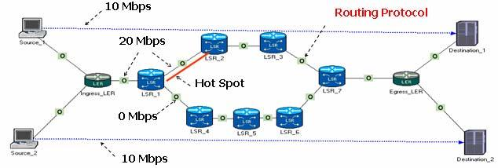
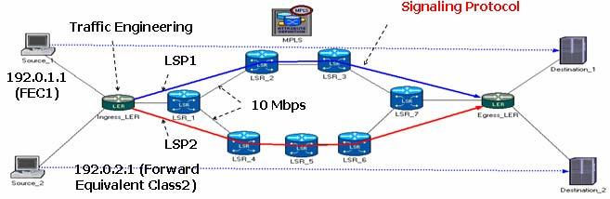

also suggest the nodes to completely suppress the
refreshes. In RSVP-TE, the LSRs are proposed to use
the HELLO protocol to detect the loss of neighboring
routers or link states. On the other hand, the soft state
design does provide some robustness to the signaling
system mechanism. By occasional rechecks, failures
in neighboring routers or link states can be detected
early.
In comparison to this, the TCP end-to-end connection
oriented controlling mechanism of the CR-LDP relies
on the ingress and egress LSRs to manage the LSP.
Based on the fact that the CR-LDP is a hard state
protocol, scalability is not an issue to consider. If a
link is to fail, the TCP process will detect this and the
ingress LSR will determine the procedures to take. In
this case, the LSP options of being strict, loose, or
pinned will define the options to take.

5-2. LSP ADAPTABILITY
In RSVP, the shared explicit (SE) reservation style is
used to set up alternative paths through “make-
before-break” procedures. This requires a session to
be established before leaving the previously used path.
The newly selected LSP will have a different tunnel
ID compared to the original one. In RSVP-TE, the
protocol does have explicit tear down messages,
although if this were to fail under high traffic
pressure, the old LSP will be left to timeout (without
being refreshed to stay alive) and will eventually be
terminated. This possible scenario could result in
serious problems for the network. First, the timeout
period is much too long for backbone networks to be
waiting for path termination, which results in a

contain the pinning option as an additional feature. In
CR-LDP, path re-optimization is conducted by the
ingress LSR, which is the most proper method to
stably control the rerouting. The process is governed
by the ingress LSR where end-to-end checking of the
sequence of operation commands is protected by the
TCP layer mechanism.

6. EXPERIMENT AND OBSERVATION

(a) Network Topology for OSPF

(b) Network Topology for MPLS
FIG.2. NETWORK TOPOLOGIES FOR MPLS AND OSPF.

For simple example to show the TE property of
MPLS, Open Shortest Path First (OSPF) may be
compared with MPLS. OSPF routing protocol can
provide traffic load balance when multiple paths have
equal costs to the destinations. However, if the
multiple paths have different costs to the destinations,
OSPF chooses a shortest path first. Therefore, traffic
is not evenly distributed to the multiple paths and it

significant waste of bandwidth. Second, the may increase network traffic load. MPLS-TE can be
remaining LSP may cause looping problems or other used in this case. MPLS uses signaling protocols to
confusions to the LSRs, which is most undesirable. disseminate the traffic to multiple paths and to do
For the case of path preemption, RSVP uses setup QoS and DS by installing LSP among the multiple
and holding priorities to determine if a new path can paths. Therefore, the traffic load at each path can be
preempt an existing path. Transport mechanism of divided based on the LSP’s traffic dissemination
RSVP, which is on raw IP, may cause problems again parameters.
for this feature support. Because preemption is often Fig. 2 shows the network topologies that were used to
required when the network is running short of simulate the MPLS TE in OPNET. Figs. 2(a) and (b)
resources, the RSVP signaling messages may get lost contain two sources, two destinations, and two
in this case. Then the path preemption feature would traffics (data flows) where the traffic requires 10
not be executed at all. Compared to this, CR-LDP Mbps (bits/sec) from a source to a destination.
relies on TCP, which shields the signaling protocol Between a source and a destination, Figs. 2(a) and (b)
by continuously checking errors as well as the include several LSRs where LSRs in Fig. 2(a) have
sequence of the data sessions executed. The rerouting been composed of OSPF and LSRs in Fig. 2(b) have
capability in RSVP may be used to re-optimize the been composed of with MPLS signaling protocols
path, which is executed by all participating nodes such as CR-LDP and RSVP-TE. In order to perform
exchanging local traffic information to reselect the the traffic engineering, the topology has been
new path. The standards for RSVP do not have the constructed as follows. Ingress LER has two input
pinning option included, although the RSVP-TE does traffics from two sources and one output traffic to

Proceedings of the First Asia International Conference on Modelling & Simulation (AMS'07)
0-7695-2845-7/07 $20.00 © 2007

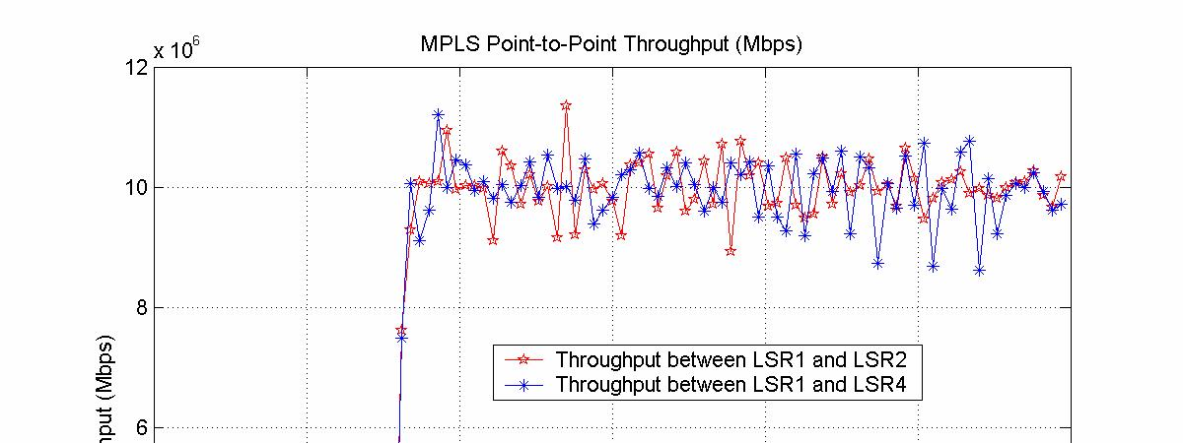
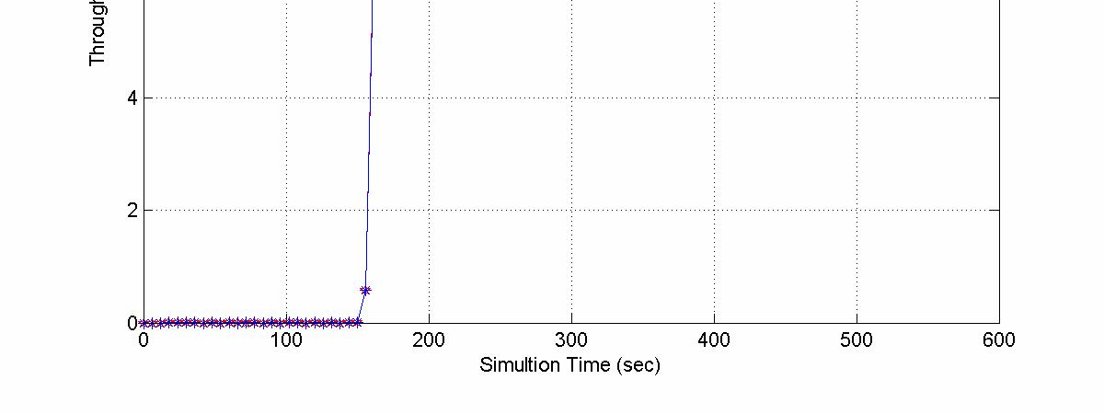
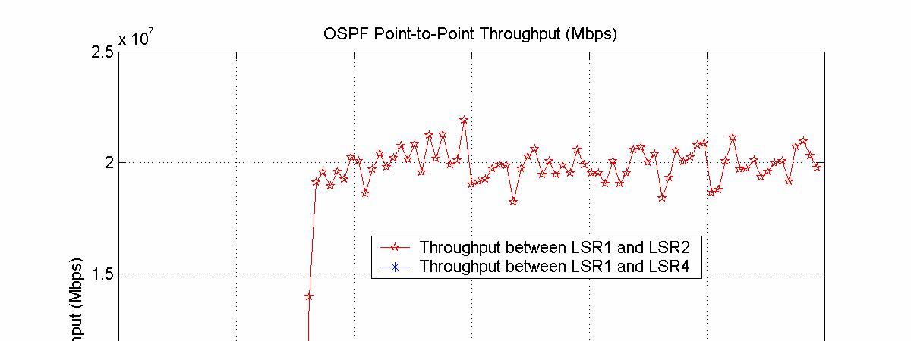
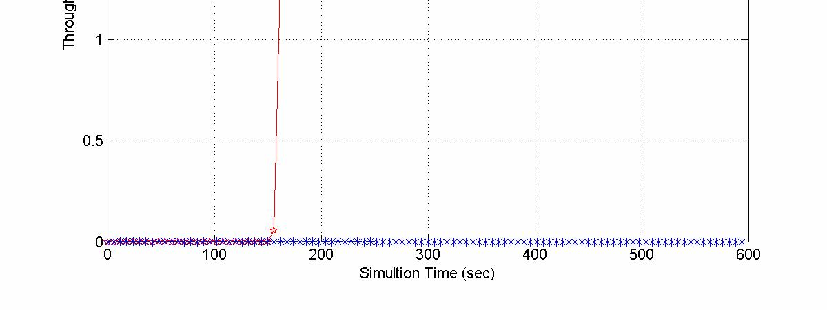

LER1. One data flow follows a route (let’s say route
A) from LER1 LSR2, LSR3 to LSR7. The other data
flow follows a route (let’s say route B) from LSR1,
LSR4, LSR5, LSR6, to LSR7. It is assumed that there
is no other background traffic in LSRs. Since all
LSRs in Fig. 2(a) are configured with OSPF, the data
flow of 20 Mbps from Ingress_LER follows the route
A since the route A provides the shortest path
compared the route B following LSR1, LSR4, LSR5,
LSR6, and LSR7. However, all LSRs in Fig. 2(b) are
configured with MPLS signaling protocols such as
CR-LDP and RSVP-TE, the data flow of 20Mbps is
separately divided into two data flows of 10Mbps and
route A and route B service each data flow 10Mbps
separately. Two LSPs are setup in the route A and the
route B. Figs 3 (a) and (b) show the graphs of
simulation results. In both figures, x axis shows the
simulation time in second unit and y axis shows the
throughput between LSR1 and LSR2 and the
throughput between LSR1 and LSR4. Based on the
results, it can be expected that in the case of OSPF,
the link between LSR1 and LSR2 causes the problem
of hot-spot; however, the link between LSR1 and
LSR4 is idle during the simulation time since it is not
used. In the case of MPLS, the link between LSR1
and LSR2 has no more problems of hot-spot and the
link between LSR1 and LSR4 is moderately used
compared to its throughput.

7. CONCLUSION
This paper explains the MPLS LSR operations based
on the basic LSR functionality of classification,
queue, and scheduling. In addition, MPLS signaling
protocols such as CR-LDP, RSVP and RSVP-TE are
summarized and analyzed based on how to set up
LSP for TE with help of the protocol messages. CR-
LDP is a hard-state protocol and capable of
establishing both strict and loose path setups with
setup and holding priority, path preemption, and path
re-optimization. RSVP inherently is a soft state
protocol that uses PATH and RESV commands to
establish a LSP. RSVP-TE has been proposed to
support ER-LSP as well as provide additional
features to RSVP and contains several specifications
to support differentiated services with RSVP for
MPLS traffic engineering networks. Based on
comparison of signaling protocols, it can be found
that RSVP has drawback in its scalability when there
are a large number of paths passing through a node
due to the periodical refreshing of the state for each
path. In the simulation, when MPLS signaling
protocols were implemented in a MPLS network of
TE, the traffic in hot spot can be reduced and the
traffic is moderately distributed into several LSPs,

which is not able to achieve in the conventional
routing protocol.

(a) Throughput of links configured with OSPF

(b) Throughput of links configured with MPLS
FIG.3. THROUGHPUT COMPARISON FOR MPLS AND OSPF.
8. ACKNOWLEDGMENT
This research was supported by the Seoul R&BD
program of Korea.

9. REFERENCES

[1] E. Rosen, A. Viswanathan, and R. Callon, ‘‘Multiprotocol Label
Switching Architecture,’’ RFC 3031, Jan. 2001.
[2] J. L. Marzo, E. Calle, C. Scoglio, and T. Anjali, “QoS on-line routing
and MPLS multilevel protection: a survey,” IEEE Commun. Mag.,
vol. 41, pp. 126-132, Oct. 2003.
[3] J.-M. Chung, E. Marroun, H. Sandhu, and S.-C. Kim “VoIP over MPL
S Networking Requirements,” Proceedings of IEEE International
Conference on Networking 2001 (IEEE ICN’01), Colmar, France,
July 11-13, 2001.
[4] J.-M. Chung, “Analysis of MPLS Traffic Engineering,” Proceedings
of the IEEE Midwest Symposium on Circuits and Systems 2000
Conference (IEEE MWSCAS’00), East Lansing, MI, USA, Aug. 8-
11, 2000.
[5] B. Jamoussi et al, “Constraint-Based LSP Setup using LDP,” IETF
RFC 3212, Jan. 2002.
[6] L. Zhang et al, “Resource ReSerVation Protocol (RSVP),” IETF RFC
2205, Sep. 1997.
[7] J. Wroclawski, “The Use of RSVP with IETF Integrated Services,”
IETF RFC 2210, Sep. 1997.
[8] D. Awduche et al, “RSVP-TE: Extensions to RSVP for LSP Tunnels,”
IETF RFC 3209, Dec. 2001.

Proceedings of the First Asia International Conference on Modelling & Simulation (AMS'07)
0-7695-2845-7/07 $20.00 © 2007

